1.Write a program to Print Fibonacci Series using recursion.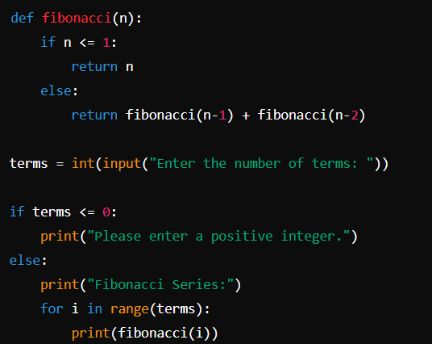

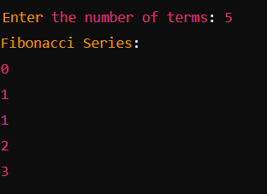

2.Write a program to check the given no is Armstrong or not using recursive function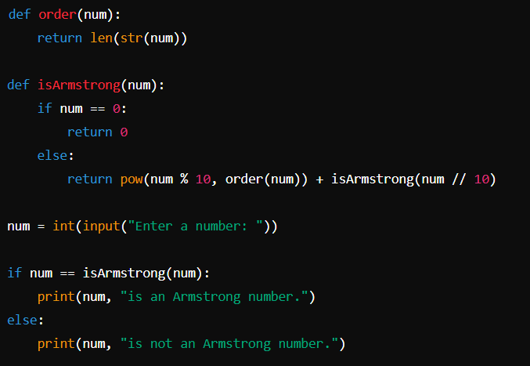

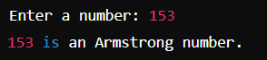

3.Write a program to find the GCD of two numbers using recursive factorization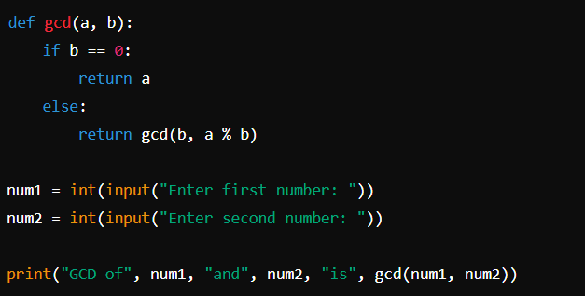

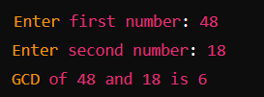

4.Write a program to get the largest element of an array.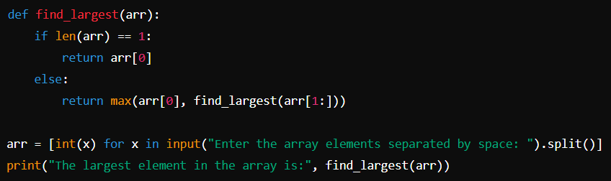

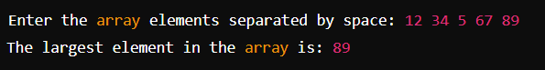

5.Write a program to find the Factorial of a number using recursion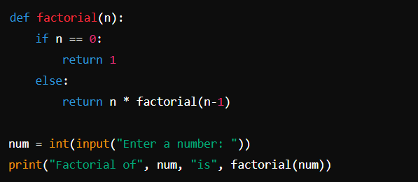

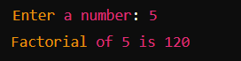

6.Write a program for to copy one string to another using recursion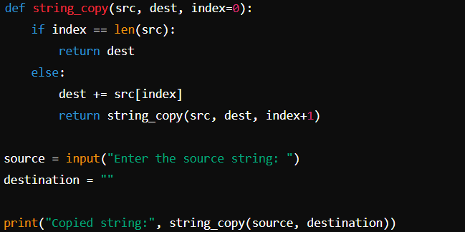

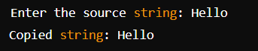

7.Write a program to print the reverse of a string using recursion:

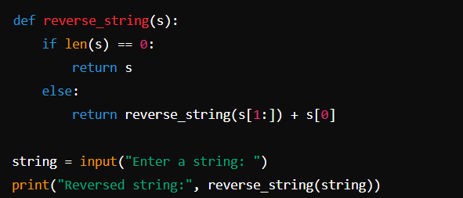

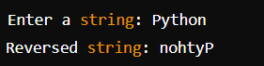

8.Write a program to generate all the prime numbers using recursion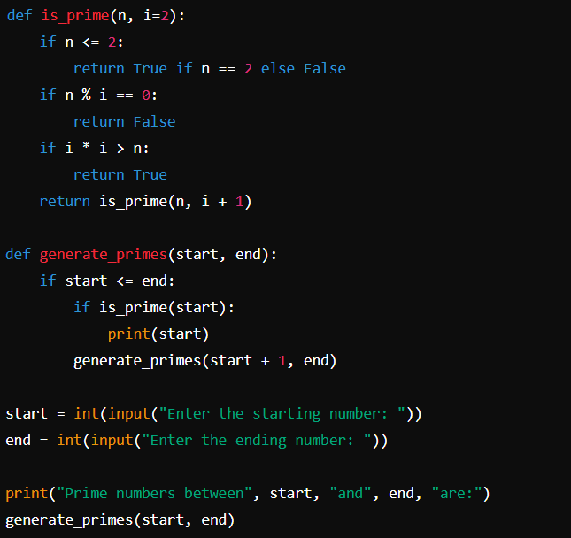

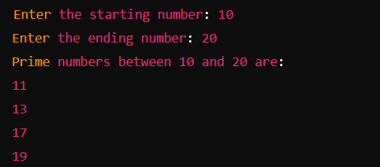

9.Write a program to check a number is a prime number or not using recursion.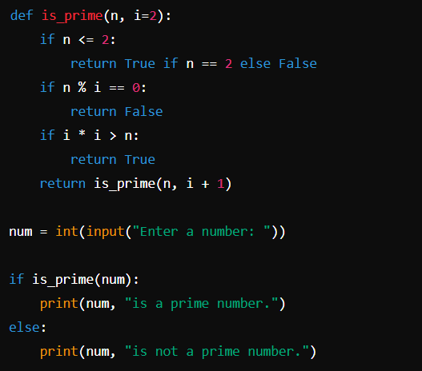  
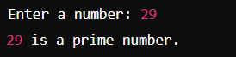

10.Write a program for to check whether a given String is Palindrome or not using recursion

